

**AI Application in Healthcare**

|  |  |  |  |
| --- | --- | --- | --- |
| Student Names Manar Almunyif | |  | |
| Student Numbers | | **441960354** | |

**Abstract**

The field of Artificial Intelligence (AI) is expanding quickly and has the potential to change the healthcare and medical industries significantly. AI can use advanced algorithms and machine learning to analyse large amounts of medical data, recognize patterns, and make predictions that can help healthcare professionals make informed decisions. Despite these advancements, there are challenges to implementing AI in healthcare and medicine. Protecting the privacy and security of sensitive medical information is a crucial issue, and strong regulations are needed to oversee the use of AI in healthcare. Further research and development are also necessary to make sure that AI is secure, effective, and fair for all patients. This paper includes AI application in various aspect of healthcare and medicine, and we point out the limitation in AI in the existing applications and propose some solutions to the existing limitations.

**Table of Content**

|  |  |
| --- | --- |
| Topic | Page |
| Abstract | 2 |
| Introduction | 4 |
| Analysis of reviewed papers | 5 |
| How AI is used in healthcare | 9 |
| Advantages of using AI in healthcare | 12 |
| Challenges of AI in Healthcare | 13 |
| The proposed solutions to AI challenges | 14 |
| Conclusion and future work | 16 |
| References | 16 |

**Introduction**

Artificial Intelligence (AI) refers to the simulation of human intelligence in machines that are designed to think and act like humans. AI technology is based on the idea that a machine can be trained to perform tasks that typically require human intelligence, such as visual perception, speech recognition, decision-making, and language translation.

In recent years, AI has found a wide range of applications in the healthcare and medical fields, leading to significant advancements in the delivery of patient care. AI has the ability to process vast amounts of medical data and make predictions based on that data, assisting healthcare professionals in making more informed decisions.

One of the most exciting areas of AI in healthcare is in the field of medical imaging, where AI has been used to accurately diagnose a range of diseases, including cancer and diabetic retinopathy. AI can also be used to develop personalized treatment plans for patients, taking into account their unique medical history and genetic information.

In addition to helping healthcare professionals make better decisions, AI is also being used to streamline administrative tasks in the healthcare industry, such as appointment scheduling and medical billing, freeing up time for healthcare professionals to focus on patient care.

Despite the potential benefits of AI in healthcare, there are also concerns that need to be addressed, such as ensuring the privacy and security of sensitive medical data and the need for robust regulations to govern the use of AI in healthcare. Nevertheless, the future of AI in healthcare looks bright, and the technology holds great promise for improving patient outcomes and the overall quality of care.

**Analysis of reviewed papers**

Caiming Zhang and Yang Lu [1] The authors conducted a comprehensive review of current and future AI research. AI is a multi-disciplinary field that encompasses information, logic, cognition, thinking, systems, and biology. It has been applied to knowledge processing, pattern recognition, machine learning, and natural language processing, and has been successfully used in areas such as automatic programming, expert systems, knowledge systems, and intelligent robots. AI not only involves logical thinking and imitation but also emotions.

Samira Yeasmin [2] showed that AI is replacing doctors and reducing mortality rates. Over the coming years, AI will change the traditional role of doctors. It is providing support to tackle many problems of healthcare. Therefore, AI is beneficial in diagnosing, treating diseases, reducing human errors, and it will also be virtually present with the patients. But there is a need for additional research in knowing the ability to take risks by AI. It will help people to know how much risk AI can take because there are numerous risky tasks in medicine.

Silvana Secinaro et al. [3] The authors offered an in-depth look at the current status of artificial intelligence in the healthcare field. The authors performed a systematic examination of existing studies related to the topic and evaluated the different ways AI is being used in healthcare, such as for medical imaging, disease diagnosis, treatment planning, and drug development. They found that AI has the potential to greatly enhance healthcare results by offering more accurate diagnoses, customized treatments, and better patient outcomes. Despite its benefits, the authors acknowledged the challenges and ethical considerations that come with implementing AI in healthcare, including privacy issues, limitations with data quality, and the need to use AI algorithms responsibly and interpret them correctly.

Thomas Davenport and Ravi Kalakota [4] The authors discussed the different ways AI is being used in healthcare, such as medical imaging, diagnosing illnesses, developing treatment plans, and finding new drugs. They emphasized the possibility of AI to better patient outcomes, decrease expenses, and increase the healthcare system's efficiency. However, the authors also acknowledged the difficulties and ethical issues that come with using AI in healthcare, such as privacy issues, issues with data quality, and the need for responsible implementation and understanding of AI algorithms. The study offered a thorough understanding of the potential of AI in healthcare and the steps required to make the most of its advantages while handling the difficulties and ethical concerns that come with it.

Guoguang Rong et al. [5] the authors presented an overview of the current state of AI in healthcare, and examine various case studies in which AI has been conducted. They presented a summary of the latest advancements in the use of AI in biomedicine, including disease diagnosis, assisted living, processing biomedical information, and biomedical research. It's evident that AI is becoming more crucial in biomedicine due to the constant advancement in AI technology and the intricate nature of biomedical issues, which AI is well-suited to tackle. AI's new capabilities offer fresh approaches to biomedicine, and the advancement of biomedicine necessitates increased capability from AI.

Amisha et al. [6] The medical field is already making extensive use of AI, including online appointment scheduling, online check-ins at medical centers, digitization of medical records, reminder calls for follow-up appointments and immunization dates, and algorithms for drug dosages and warnings about adverse effects while prescribing multiple drugs. the authors pointed out that it is crucial that primary care physicians familiarize themselves with the future advancements in AI and the new direction the world of medicine is heading in. The aim should be to achieve a delicate balance between the effective use of automation and AI and the human qualities and judgment of well-trained primary care physicians.

Vivek Kaul et al. [7] studied the possibilities for AI's role in gastrointestinal disease in which they found they are limitless including: improving diagnostic accuracy in endoscopy, streamlining endoscopy workflows, and more accurately assessing the risk of common gastrointestinal conditions such as bleeding and neoplasia. However, the authors illustrated that there is a need for further research and validation of AI algorithms and their applications. More clinical data is required to show their effectiveness, value, and impact on patient care and outcomes. Additionally, cost-effective AI models and products must be developed to enable physicians, practices, and hospitals to incorporate AI into their daily clinical practice.

Wan-Jung Chang et al. [8], The authors conducted a deep learning-based wearable system for recognizing medicine for visually impaired individuals. The system includes a pair of smart glasses, a waist-mounted device for recognizing drug pills, a mobile application, and a cloud management platform. The proposed system utilizes deep learning to correctly identify drug pills, avoiding the risk of taking incorrect medication. The results of the experiments indicate that the accuracy of the proposed system is up to 90%, effectively achieving the goal of providing accurate medication for visually impaired people.

Xiao Fu [9], discussed in this thesis the application and advancement of AI in the medical industry, highlighting that as AI technology continues to advance, significant progress can be made in the medical field, leading to improved patient outcomes. Currently, AI is widely utilized in many developed countries, bringing convenience to people's lives and work. Specifically in the healthcare field, AI is widely used and developed, particularly in areas such as health management, hospital management, medical imaging, risk management, and more. But they are some serious problems in the application of Al in medical field which are: the number of samples is small and there is a lack of authoritative doctors to label samples. The other problem is the serious disconnect between the actual demand for medical care and the application market situation.

He XIA et al. [10], The recognition of emotions is a crucial aspect for the advancement of artificial intelligence in the future. It requires advancements not only in computer science but also in related fields like psychology and neurocognition. The authors addressed the ethical concerns surrounding this technology to prevent any negative consequences and establish clear guidelines. These discussions should take place beforehand to anticipate the impact of technological innovation on society and minimize the possibility of irreversible situations.

|  |  |  |
| --- | --- | --- |
| **Ref #** | **Proposed** | **Limitations** |
| [2] | analyzes the benefits of artificial intelligence in medicine and answers if it will be beneficial or dangerous for a human being | There is required additional research about the risks of using AI in medicine since the existing papers talk more about the beneficial side of it |
| [3], [4] | An overview of the current AI application in the health care system | The use of AI in healthcare often requires access to sensitive patient data, and there are concerns about privacy and the protection of personal information. |
| [5] | recent advancements in AI applications for biomedicine including disease diagnostics and other uses | A system they discussed called ML has limitations in biomedical diagnosis. |
| [7] | The study focus on the potential applications for AI in GI disease | The current results of AI use in GI disease needs additional clinical data to prove the efficacy of the application |
| [9] | the application and advancement of AI in the medical industry | the number of samples is small and there is a lack of authoritative doctors to label samples. Alo, there is a serious disconnect between the actual demand for medical care and the application market situation. |

*Table (1): Limitations in the reviewed studies*

After we analyzed the previous papers, we can see how much important AI has been generally and particularity in the healthcare field. There have been some applications of AI in medicine and healthcare that has potential in improving patient outcomes, reduce costs, and enhance the efficiency of the healthcare system. AI has been used in radiology, imaging, biomedicine, and gastrointestinal diseases.

But with all the benefits for AI applications, there are some limits and concerns. There is not enough research about the risks of using AI in medicine, Also there are some concerns about the privacy of information since the AI requires access to data and that might put this data in risk. Also, the quality of the data that is given to the AI is a concern because it there was any mistakes in them it could lead to serious problems. There is a limited understanding among healthcare professionals and the general public about the capabilities and limitations of AI, which can lead to unrealistic expectations and resistance to its adoption.

**How AI is used in healthcare:**

AI has been widely used in healthcare and medicine, here we present some of the most important uses of AI in healthcare:

1. **Medical diagnosis:** AI can help doctors diagnose medical conditions by analyzing medical images, such as X-rays, CT scans, and MRIs. AI algorithms can identify patterns and anomalies that may not be immediately noticeable to a human doctor, potentially leading to earlier and more accurate diagnoses. For example, AI has been used to detect breast cancer in mammograms with higher accuracy than human radiologists.
2. **Drug discovery:** AI can help speed up the drug discovery process by analyzing large datasets and identifying potential drug candidates. This can help reduce the time and cost associated with developing new drugs. For example, AI algorithms have been used to analyze molecular structures and predict the efficacy and safety of potential drug candidates.

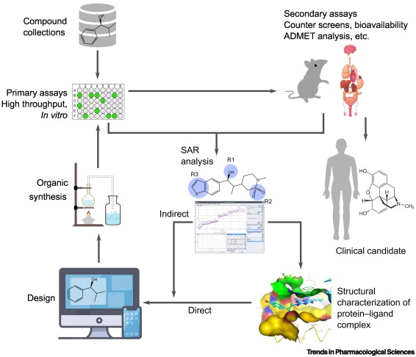

Fig (1): Example of drug discovery in pharmacological sciences

1. **Personalized medicine:** AI can help doctors create personalized treatment plans by analyzing a patient's genetic information and medical history. This can help doctors tailor treatments to individual patients, potentially leading to better outcomes. For example, AI has been used to analyze genomic data and identify genetic markers that can help predict a patient's response to certain treatments.
2. **Remote patient monitoring:** AI can be used to monitor patients remotely, collecting data on vital signs, symptoms, and other health information. This can help doctors identify potential health issues before they become serious and provide more personalized care to patients. For example, AI-powered wearables can collect and analyze data on a patient's heart rate, blood pressure, and other vital signs, alerting doctors to potential health issues in real-time.
3. **Health chatbots:** AI-powered chatbots can assist patients with basic healthcare needs, such as scheduling appointments, answering health-related questions, and providing guidance on managing chronic conditions. This can help reduce the burden on healthcare providers and improve patient access to care. For example, chatbots have been used to provide mental health support to patients, offering advice and counseling to those in need.

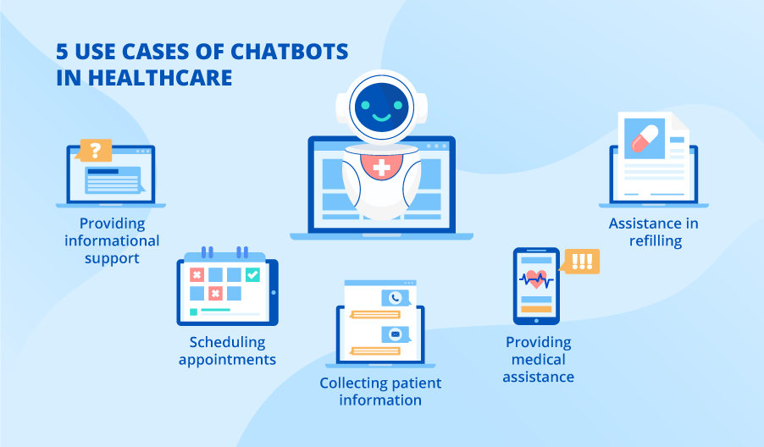

Fig (2): Uses of AI chatbots in healthcare

1. **Predictive analytics:** AI can be used to analyze large amounts of healthcare data, such as electronic health records, to identify patterns and make predictions about future health outcomes. This can help doctors identify patients who may be at risk for certain conditions and intervene early to prevent or manage those conditions.
2. **Medical research:** AI can be used to analyze medical research data, such as clinical trials, to identify new insights and potential treatment options. For example, AI has been used to identify potential drug combinations that may be effective in treating certain cancers.
3. **Patient engagement:** AI can be used to improve patient engagement by providing personalized recommendations and support. For example, AI-powered virtual assistants can help patients manage chronic conditions by providing reminders to take medication, offering tips on healthy habits, and answering health-related questions.
4. **Clinical decision support:** AI can be used to provide doctors with real-time clinical decision support, helping them make more informed treatment decisions. For example, AI algorithms can analyze patient data to provide recommendations for the most effective treatments for specific conditions.
5. **Medical billing and coding:** AI can be used to automate medical billing and coding processes, reducing the time and resources required for these tasks. For example, AI algorithms can analyze medical records to automatically assign billing codes and identify errors or discrepancies.

**Advantages of using AI in healthcare:**

AI has the potential to revolutionize medicine by improving the speed, accuracy, and efficiency of healthcare services. Here are the most important advantages of AI in healthcare:

* Provide real-time data: this can assist doctors and other medical professionals in making critical clinical decisions. The prompt availability of accurate information can lead to improved preventative steps, cost-savings, and reduced patient wait times. Moreover, real-time analytics can improve physician-patient relationships by making essential patient data available on mobile devices and providing alerts to doctors and nurses about urgent changes in a patient's status.
* Streamlines tasks: AI in medicine also streamlines various tasks, such as appointment scheduling, patient tracking, and insurance claim review, which saves precious productivity hours and reduces administrative strain. Additionally, AI can assist medical professionals in researching diseases, detecting symptoms early in the illness's progression, and contributing population information to shared networks. This, in turn, helps to improve patient outcomes, save resources, and reduce healthcare costs.
* Save time and research: As AI automates more important processes, healthcare professionals have more opportunities to diagnose ailments and assess patients. This leads to saved time and more efficient operations for medical establishments, resulting in cost savings.
* Assist research: AI is a valuable tool in medical research, as it allows researchers to gather and analyze vast amounts of data from multiple sources. With access to a rich and ever-expanding pool of information, researchers can more effectively study and combat deadly diseases. Real-time data also plays an important role in research, as it can provide valuable insights into disease patterns and treatment outcomes.
* Increased efficiency: AI can automate many healthcare tasks, such as medical billing and coding, freeing up time for doctors and other healthcare professionals to focus on patient care.
* Cost savings: By improving the efficiency of healthcare services and reducing the need for unnecessary tests and procedures, AI has the potential to reduce healthcare costs for patients and providers.

**Challenges of AI in Healthcare**

While AI has the potential to revolutionize healthcare, there are also some challenges that need to be addressed. Here are some of the main challenges:

* **Data quality:** AI algorithms rely heavily on data inputs to make accurate predictions or decisions. However, the quality and completeness of data can vary, which can lead to incorrect or biased results. Ensuring that data is accurate, complete, and representative of diverse populations is crucial for successful AI implementation in healthcare.
* **Bias and fairness:** AI algorithms can be biased based on the data they are trained on, which can lead to unfair treatment and misdiagnosis of certain patient groups. Efforts must be made to ensure that AI systems are unbiased and fair in their recommendations.
* **Interoperability:** Healthcare data is often siloed across different systems and institutions, making it difficult to aggregate and analyze data at scale. AI systems require access to diverse and comprehensive data to be effective, which can be challenging in the fragmented healthcare landscape. Efforts to standardize data formats and improve data sharing across systems are necessary to overcome this challenge.
* **Privacy and security:** AI systems often require access to sensitive patient data, such as medical records and genetic information. Protecting patient privacy and ensuring data security is critical to prevent unauthorized access or breaches. As AI becomes more widespread in healthcare, it is essential to establish robust policies and protocols for data privacy and security.
* **Regulatory hurdles:** The use of AI in healthcare is subject to regulatory oversight, which can create barriers to implementation. Regulations around data privacy, clinical trial design, and approval processes can be complex and time-consuming. Ensuring that AI applications in healthcare comply with regulatory requirements is essential to ensure patient safety and trust.
* **Ethical concerns:** The use of AI in healthcare raises ethical questions around issues such as transparency, bias, and accountability. AI systems can produce results that are difficult to explain or interpret, making it challenging to ensure accountability and prevent unintended consequences. Addressing ethical concerns around AI in healthcare is essential to maintain patient trust and ensure responsible use of technology.
* **Cost:** Implementing AI in healthcare can be expensive, particularly for smaller healthcare organizations that may not have the resources to invest in advanced technology. The cost of implementing and maintaining AI systems may also be a barrier for some healthcare organizations.

**The proposed solutions to AI challenges in healthcare**

There are several ways to address the challenges of AI in healthcare:

* *To solve the issue of* *data quality* in healthcare AI, several strategies can be employed:
  + Data cleaning: This involves the removal of inaccurate or incomplete data from datasets. It can be done manually or through automated tools.
  + Data standardization: Standardizing data formats and terminologies can help ensure consistency and accuracy across different sources of healthcare data.
  + Data governance: Establishing clear guidelines and policies for data collection, management, and use can help ensure data quality and integrity.
  + Data validation: This involves verifying the accuracy and completeness of data through various techniques such as data profiling, data matching, and data sampling.
  + Machine learning algorithms: Using machine learning algorithms can help identify patterns and anomalies in healthcare data, thereby improving data quality.
  + Collaboration: Collaboration between healthcare providers, data scientists, and technology experts can help ensure that data quality is a priority and that best practices are followed.
* *To address the potential for biased algorithms*, there should be a greater emphasis on transparency in the development and deployment of AI systems. This includes regularly auditing algorithms for fairness and incorporating diverse perspectives in the development process.
* *To ensure that AI is effectively integrated into clinical practice*, there needs to be a greater emphasis on training and education for healthcare professionals. This includes providing resources for clinicians to learn about the capabilities and limitations of AI, as well as opportunities for hands-on experience with AI systems.
* *Data privacy and security* can be improved by implementing strict protocols for accessing and sharing patient data, as well as ensuring that AI algorithms comply with relevant regulations and standards.
* *To address regulatory hurdles*, healthcare organizations must ensure that their AI technologies comply with relevant regulations and undergo rigorous testing to ensure their safety and effectiveness. They must also establish protocols for obtaining patient consent and ensuring the privacy and security of patient data used in AI algorithms. Collaboration between regulatory bodies and healthcare organizations is essential to ensure that AI technologies are effectively regulated and integrated into healthcare systems.
* *To address the ethical concerns*, it is important to ensure that AI algorithms are developed and tested on diverse and representative datasets, and that they are regularly audited for biases. Additionally, there should be transparency in how AI systems make decisions, with clear explanations provided to healthcare providers and patients.
* *To address the issue of cost and accessibility*, there needs to be a focus on developing affordable and user-friendly AI systems that can be easily integrated into existing healthcare infrastructure, particularly in low-resource settings. This includes exploring opportunities for public-private partnerships and collaborations to support the development and deployment of AI in healthcare.

**Conclusion and Future Work**

In conclusion, Artificial Intelligence (AI) has the potential to significantly impact the healthcare and medical industries, leading to better patient outcomes and a higher quality of care. AI's ability to process vast amounts of medical data and make predictions based on that data has already shown promising results in the areas of medical imaging and personalized treatment planning. Additionally, AI is being used to streamline administrative tasks, freeing up time for healthcare professionals to focus on patient care.

However, the implementation of AI in healthcare and medicine is not without its challenges. Ensuring the privacy and security of sensitive medical data is a major concern, and there is a need for robust regulations to govern the use of AI in healthcare. There is also a need for further research and development to ensure that AI is safe, effective, and fair for all patients. Future work in the field of AI in healthcare should focus on addressing the challenges mentioned above and exploring new ways to apply AI technology to benefit patients and healthcare professionals alike.

**References:**

[1] Zhang, C. and Lu, Y. (2021). Study on Artificial Intelligence: The State of the Art and Future Prospects. Journal of Industrial Information Integration, [online] 23, p.100224. doi:https://doi.org/10.1016/j.jii.2021.100224.

[2] Yeasmin, S. (2019). Benefits of Artificial Intelligence in Medicine. [online] IEEE Xplore. doi:https://doi.org/10.1109/CAIS.2019.8769557.

[3] Secinaro, S., Calandra, D., Secinaro, A., Muthurangu, V. and Biancone, P. (2021). The role of artificial intelligence in healthcare: a structured literature review. BMC Medical Informatics and Decision Making, 21(1). doi:https://doi.org/10.1186/s12911-021-01488-9.

[4] Davenport, T. and Kalakota, R. (2019). The potential for artificial intelligence in healthcare. Future Healthcare Journal, [online] 6(2), pp.94–98. doi:https://doi.org/10.7861/futurehosp.6-2-94.

[5] Rong, G., Mendez, A., Bou Assi, E., Zhao, B. and Sawan, M. (2020). Artificial Intelligence in Healthcare: Review and Prediction Case Studies. Engineering, [online] 6(3). doi:https://doi.org/10.1016/j.eng.2019.08.015.

[6] Amisha, Malik, P., Pathania, M. and Rathaur, V. (2019). Overview of artificial intelligence in medicine. Journal of Family Medicine and Primary Care, [online] 8(7), p.2328. doi:https://doi.org/10.4103/jfmpc.jfmpc_440_19.

[7] Kaul, V., Enslin, S. and Gross, S.A. (2020). History of artificial intelligence in medicine. Gastrointestinal Endoscopy, [online] 92(4), pp.807–812. doi:https://doi.org/10.1016/j.gie.2020.06.040.

[8] Chang, W.-J., Yu, Y.-X., Chen, J.-H., Zhang, Z.-Y., Ko, S.-J., Yang, T.-H., Hsu, C.-H., Chen, L.-B. and Chen, M.-C. (2019). A Deep Learning Based Wearable Medicines Recognition System for Visually Impaired People. [online] IEEE Xplore. doi:https://doi.org/10.1109/AICAS.2019.8771559.

[9] Fu, X. (2019). Application of Artificial Intelligence Technology in Medical Cell Biology - IEEE Conference Publication. [online] Ieee.org. Available at: <https://ieeexplore.ieee.org/document/8806386>.

[10] XIA, H., WU, J., SHEN, X. and YANG, F. (2020). The Application of Artificial Intelligence in Emotion Recognition. [online] IEEE Xplore. doi:https://doi.org/10.1109/ICHCI51889.2020.00021.